Global Rain developed a full-stack client/server dashboard application for Grazioso Salvare to help identify dogs suitable for search-and-rescue training using the Austin Animal Center Outcomes dataset stored in MongoDB.
This dashboard allows the client to filter animals by rescue type and visualize results using an interactive table, a breed distribution chart, and a geolocation map.

Required Functionality
The dashboard meets the required functionality by providing:
- Interactive rescue-type filter options (Reset, Water, Mountain/Wilderness, Disaster/Tracking)
- A data table that updates dynamically based on filter selection
- A geolocation map that updates based on the selected record in the table
- A second chart (breed distribution pie chart) that updates dynamically
- Grazioso Salvare branding (logo) and a unique identifier (student name)

Screenshot Proof (Required)
✅ Insert your screenshots below (each screenshot must show the logo + “Pablo Fajardo”).
Starting State (Reset / All)
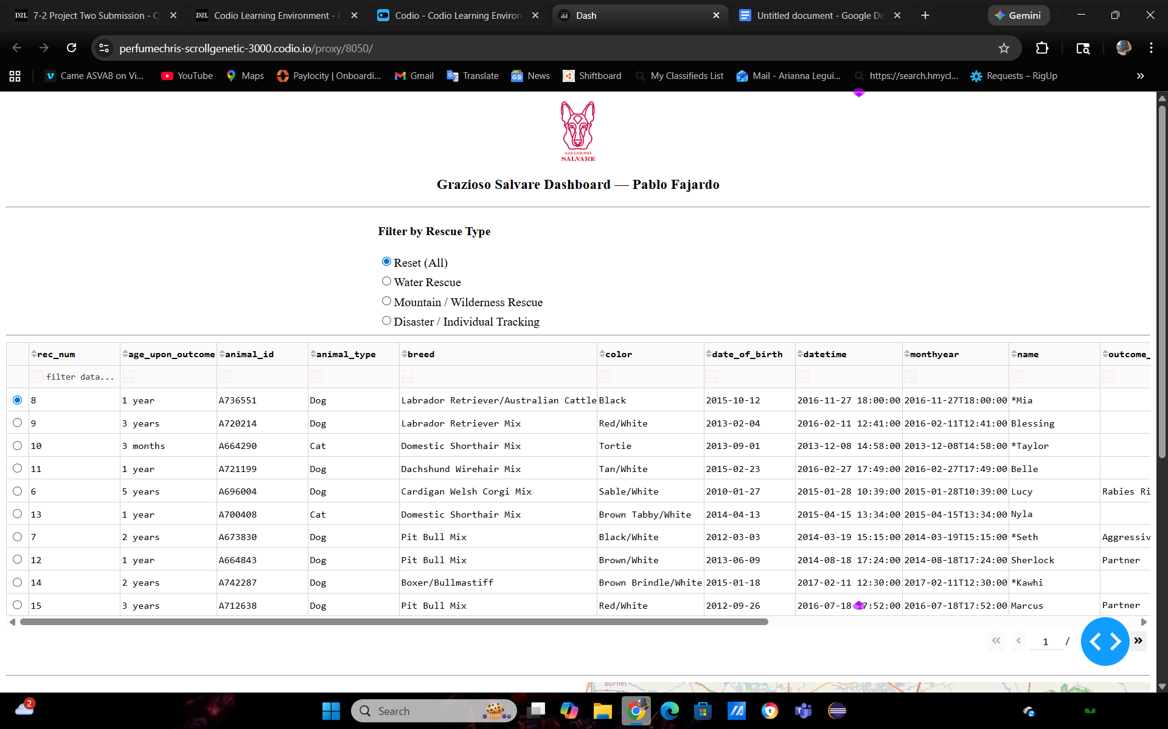
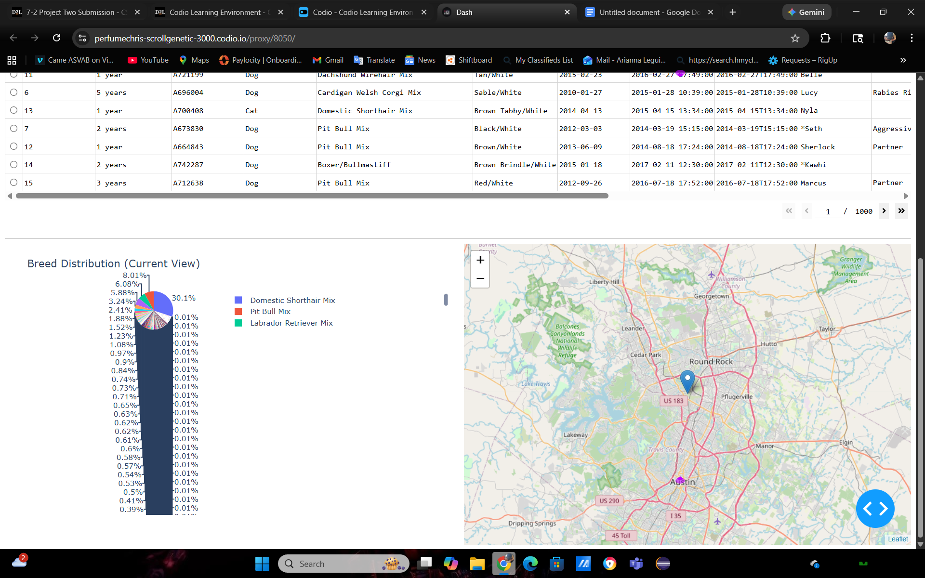
Water Rescue Filter Applied
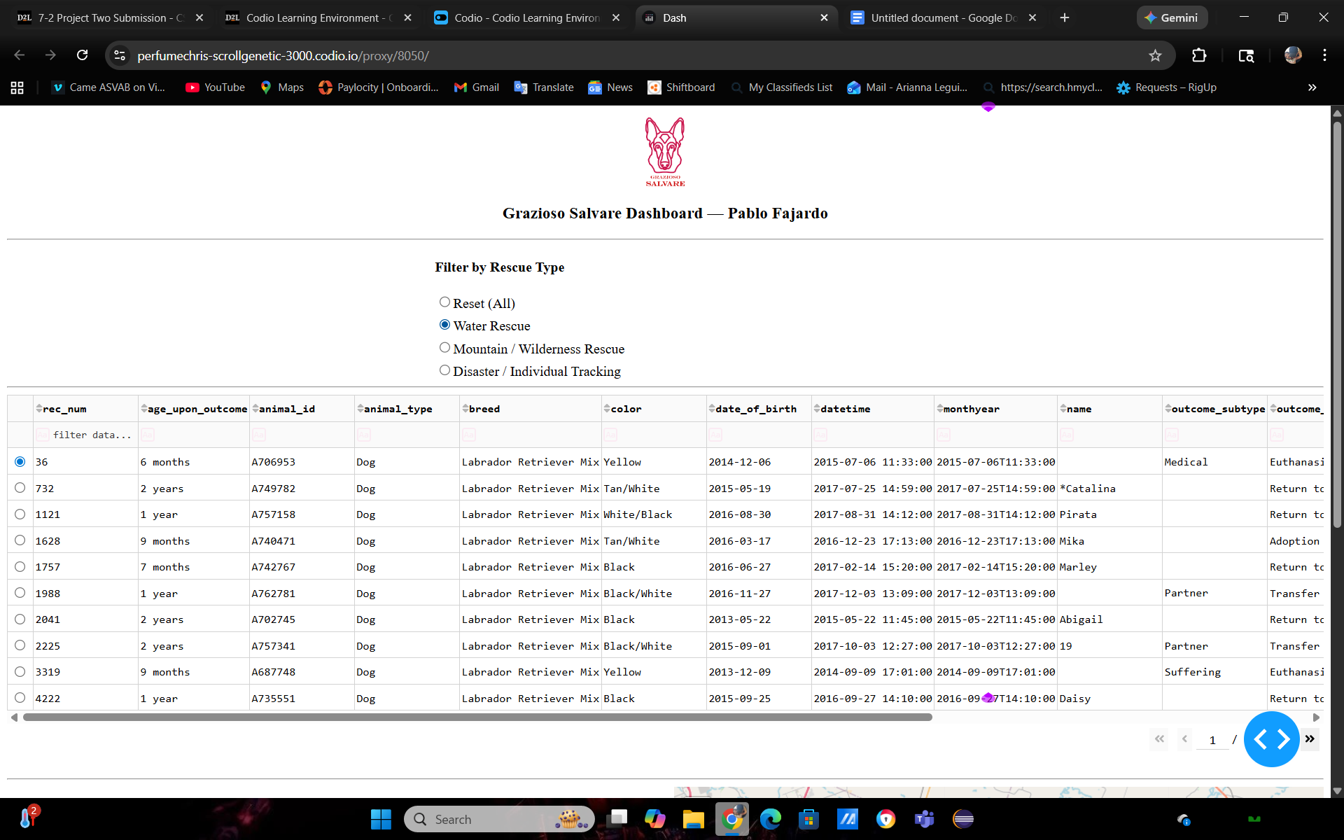
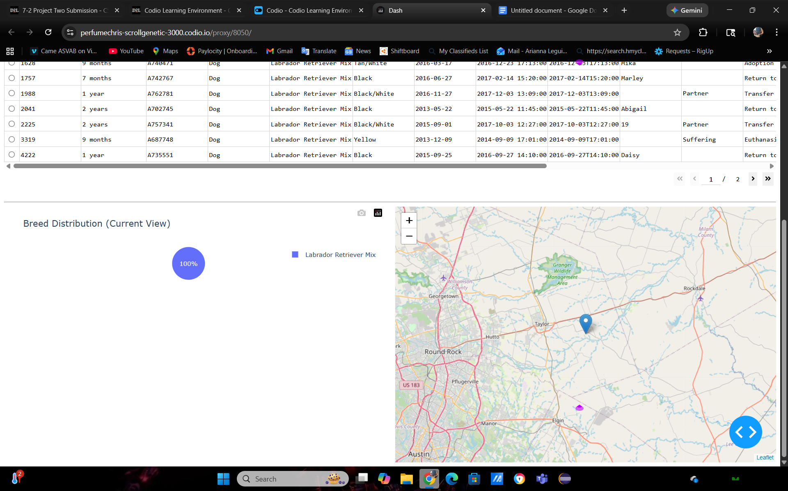
Mountain / Wilderness Rescue Filter Applied

Figure 4 — Disaster / Individual Tracking Filter Applied


Tools Used and Rationale
MongoDB was used as the model component because it provides:
- Flexible document-based storage for the AAC dataset
- Fast, JSON-style querying (ideal for filter-based rescue queries)
- Strong Python integration through the PyMongo driver
- Easy handling of additional fields such as location_lat, location_long, and age_upon_outcome_in_weeks

Python + PyMongo
A custom Python CRUD module was used to isolate database logic from the dashboard UI. This supports the MVC pattern by keeping data access clean, reusable, and easier to maintain.

Dash + JupyterDash
The Dash framework was used to create the client-facing web dashboard because it supports:
- Interactive UI controls (radio buttons for rescue filters)
- Reactive updates using callback functions
- A built-in interactive DataTable component
- Easy integration with Plotly charts and Dash Leaflet maps
JupyterDash was used to run the dashboard inside the Codio/Jupyter environment via the proxy URL.

How to Reproduce / Run the Project

Required Files
- ProjectTwoDashboard.ipynb (dashboard notebook)
- AnimalShelterCRUD.py (CRUD database interface module)
- Grazioso Salvare logo image file (PNG/JPG)

Steps to Run
- Open Codio and launch JupyterLab.
- Ensure MongoDB is running and the AAC dataset is loaded into:
  - Database: aac
  - Collection: animals
- Confirm ProjectTwoDashboard.ipynb and AnimalShelterCRUD.py are in the same folder.
- Open ProjectTwoDashboard.ipynb and run all cells.
- Open the generated proxy link displayed in the output (format similar to):
  - https://<codio-box>.codio.io/proxy/8050/
- Use the radio buttons to apply each rescue filter and verify the table and charts update.

Steps Taken to Complete the Project
Verified the MongoDB database and collection were created and populated correctly.
Built a Python CRUD module to perform database operations using PyMongo.
Developed the dashboard layout including:
  - Logo and unique identifier
  - Rescue-type filter controls
  - Interactive data table
  - Breed distribution chart
  - Geolocation map
Implemented Dash callbacks to query MongoDB based on the selected filter and update all widgets dynamically.
Tested each required filter state and captured screenshots as proof of functionality.

Challenges and Solutions
Challenge: The dashboard initially displayed a 127.0.0.1 URL that could not be opened in Codio.
Solution: Configured JupyterDash proxy support so the dashboard runs using a /proxy/8050/ URL accessible in the browser.
Challenge: MongoDB returned an _id field as an ObjectId type that can break the DataTable.
Solution: Removed the _id column from the DataFrame before sending the data to the DataTable.

Resources / References
Austin Animal Center. (2020). Austin Animal Center Outcomes [Data set]. City of Austin, Texas Open Data Portal. https://doi.org/10.26000/025.000001
Dash Documentation: https://dash.plotly.com/
PyMongo Documentation: https://pymongo.readthedocs.io/
Dash Leaflet Documentation: https://dash-leaflet.herokuapp.com/

